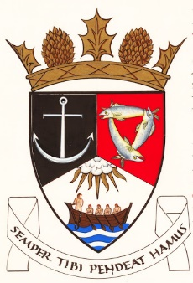
THE ROYAL BURGH OF KILRENNY, ANSTRUTHER & CELLARDYKE COMMUNITY COUNCIL
Monday !0 February 2025 7:30pm in the lower town hall

A G E N D A – February 2025Meeting

- Welcome & Declarations of Interest
- Approval of Minutes & Matters Arising
- Questions from the public
- Input re: Multi Use Path Group
- Councillors’ Reports
- Planning/Licensing Matters
- Common Good Fund
- Silverdykes Fund

- Report from Fife Local Development Plan meeting

- Web site

- Folly lights

- Anstruther Access to cash
- Secretary’s Report
- Treasurer’s Report
- Representation from other groups
- Floral Group
- Murray Library Trustees
- AOCB

Date of next meeting 10 March 2025

