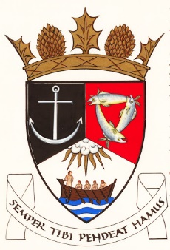
THE ROYAL BURGH OF KILRENNY, ANSTRUTHER & CELLARDYKE COMMUNITY COUNCIL
Monday 10 March 2025 7:30pm in the lower town hall

A G E N D A – March Meeting

- Welcome & Declarations of Interest
- Approval of Minutes, Matters Arising and Action Points
- Questions from the public
- Input re: Multi Use Path Group
- Councillors’ Reports
- Planning/Licensing Matters
- Silverdykes Fund
- Common Good Fund
- Cellardyke Pool parking
- Short Term Lets
- Twinning, Local Place Plan and Web site
- Secretary’s Report
- Treasurer’s Report
- Representation from other groups
- Floral Group
- Murray Library Trustees
- AOCB

Date of next meeting 14 April 2025

