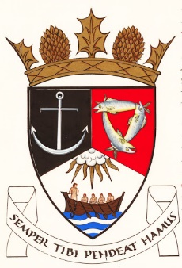
THE ROYAL BURGH OF KILRENNY, ANSTRUTHER & CELLARDYKE COMMUNITY COUNCIL
Monday 14 october 2024 7:30pm in the lower town hall

A G E N D A – October Meeting

- Welcome & Declarations of Interest
- Approval of Minutes & Matters Arising
- Questions from the public
- Input re: Multi Use Path Group
- Councillors’ Reports
- Planning/Licensing Matters
- Common Good Fund
- Silverdykes Fund
- Waid Community Campus
- Twinning
- Secretary’s Report
- Treasurer’s Report
- Representation from other groups
- Floral Group
- Murray Library Trustees
- AOCB

