Minutes
The Royal Burgh of Kilrenny, Anstruther & Cellardyke Community Council
13 January 2025 7:30pm at the Lower Town Hall| Meeting called to order by Louis Theran

In Attendance
Louis Theran, Phil Wall, Paul Ambrose, Neil Anderson, Bill Bruce, Martin Dibley, Kevin Lancaster, Lorna Jones, Cllr Fiona Corps, Cllr Alycia Hayes,
1 members of public present
Apologies – Raymond Davis, Margaret Hellicar, Julie Lautredou, Christine Wilson, Cllr Sean Dillon, Carl van der Lee,

Welcome & Declaration of Interest
MD declared an interest in the common good fund application (item 8). Will recuse.

Approval of Minutes & Matters Arising
Minutes approved by NA and seconded PW . Matters Arising
Action Points from last meeting
Send out Silverdykes applications for those attending meeting – MH Done
Contact Daryl Wilson costs and age of old lights – MH – Before her time and I have asked LJ but before her time too ie before 2016. KL doesn’t think they are that old (e.g., 10–12 years). Martin: roughly £120 each. Voted to gift them, KL objects. AH says there is no Pittenweem CC. Aberdeen CC has shown interest.
Car park signs – MH – see Secretary’s report.

Questions from the public
Graham Ellery: Weather permitting would it be possible to have the saltire flying from the flagpole
for Burn's night?
MH: rigging was damaged, not sure if possible. KL: Maybe possible. Needs a weighted collar; will look into getting it by Burns Night.

Presentation from Cellardyke Tidal Pool Ltd
Andy Hancock presented an update on the status of the Cellardyke Tidal Pool.
Last year’s pool renovation comprises phases 1 and 2 of the project. Phase 3 is ongoing. Phase 3 is to create ramp access for non-ambulant people, children in prams, heavy model boats. Last year, quoted at £125000; not viable. New proposal: for path along the sea wall near the play park that doubles back. This will not comply with the equalities act for non-assisted wheelchairs. Cost estimate for this is £60000. Funding applications have been made to Silverdykes plus intended applications to Crown Estates; Fife Environmental Trust with March deadlines. Plan is to get the technical details in place by Feb and do the work in Sept.
Cellardyke Tidal Pool Ltd is looking for public liability insurance for pool maintenance, which is necessary to take over the lease. The AGM is on 22 Jan.
There was a meeting with contractor for electricity, mains water, waste water.
Parking near the tidal pool continues to be an issue. This generated quite a bit of discussion on the topic and the lack of progress. There was general agreement among CC and tidal pool that it is desirable to ban campervans and overnight parking, and that FCCT should implement this with speed. Councilor FC informed the CC that there is no way to implement anything this Summer. Councilor AH said that the first step is changing the designation to a parking lot. The CC expressed dismay that Robbie Blyth’s previous visit hadn’t started a process. There was a decision that we should ask if Robbie is available to return to a CC meeting.

Input re Multi Use Path
CvdL was not present. Here is a written report:
12 Jan 2025
Joint Working Group updates – Pittenweem to Anstruther
a) Land negotiation progress and programme are still ongoing and we expect a further update from Savills who are chasing land agents and final updated plans with Fife Council which are needed for Seabox / Tradesbox and their Land Agents Bidwells – DoNM Friday 24th Jan 2025, Murray Studios- Progress Meeting.
b) Dreelside Park northern path - end bollard required. This will be taken care of with the Small Works contract.
c) Future Pittenweem to Anstruther programme and funding. It is imperative that land acquisitions move forward at pace.
d) Adoption of SUPs - The path parallel with A917 will be adopted. The Core Path will be maintained as per the recent agreement with a third party. Current Active Travel discussions are taking place within FC about adopting paths that do not run parallel with roads.
Anstruther Shared Use Path Group Updates
a) Barnett’s to St Andrews Road edge lining. This will be carried out in the Small Works Contract
b) No further actions on Safer Routes to School.
7) FC Small Works Contract programme progress on signposting especially Metaflake to St Andrews Road. Photos of proposed lower kerb locations have been taken, and Andrew Burns will share sign post details etc prior to erection.
8) Windmill Road to Kilrenny: a new contract to cover Active Travel routes will include maintenance of verges and weed control.
-----
There was discussion of whether the 40 zone in Killrenny near the multi-use path is too fast and what, if anything can be done. Cll AH said the speed limit can be reduced where the path is, and this will be passed on to active travel.

Councillors’ Reports
- Cllr Fiona Corps

- SHORT TERM LET CONTROL ZONES IN FIFE
- At Cabinet Committee last week, I proposed an amendment to the officers' recommendations regarding the need for STL Control Zones specifically within highly saturated areas in FIFE.
- My amendment to Cabinet last week was not to stop tourism nor ban Short Term Lets but to highlight the fact that in some parts of Fife there are areas where some form of control over the volume of STL could be implemented. Elie and Earlsferry in particular see 60% of their current housing stock used as Second Homes, STL or both with Anstruther, Kilrenny, St Andrews and Largo not far behind.
- To implement a STL Control Area simply gives the community a voice and does not stop new STL coming to fruition. The owner simply has to go through the planning process to proceed. This in turn will allow Fife Council to assess the applications and also allow communities to consult through the planning application process.
- You can read more about the planning application process by searching for National Planning Framework 4 or NPF, specifically Policy 30 where you will see holiday let requirements.
- Positives and Negatives
- I agree there are so many great benefits regarding the tourism industry in Fife. Especially the economic benefits. In 2023, it was estimated that there was a total of 610,000 overnight tourism visits to Fife and a total overnight tourism spend of £338 million. Tourism also gives us the opportunity to showcase the beauty of Fife and of course the employment opportunities that tourism brings to our local communities.
- There are also negatives associated with tourism were: Overcrowding, increased litter, a negative carbon footprint / impact on climate change and a decline in population and in the school roles. There was also concern raised by local people who state that tourism does create jobs but quite often there are no affordable accommodation in which the workers can stay.
- Perceptions on the Local Area
- Around a third of Scotland residents feel that the area they live in is undoubtedly a holiday or short break destination (32%). 33% feel their area is visited for holidays and short breaks by some people.
- For those living in tourism areas, 84% agree that locally tourism supports jobs in food, retail and other sectors. 51% feel it adds to the amount of traffic on the roads and results in congestion and delays.
- I care deeply about the East Neuk and the people who live here. Our local businesses do extremely well over the summer months but must make allowances for the winter season when they see their takings drop dramatically. I am aware that there is no quick fix or 'Silver Bullet' to the current situation and that STL are not the only issue when discussion our current housing crisis. I do believe we need to build more homes; we need to manage student accommodation better and we need to find affordable solutions for young people and their families to live locally. I have been listening to the local people and yes tourism is extremely important, but there is a desperate need to find a BALANCE.

- Cabinet decision:
- Short-term Let Control Areas
- (4) Cabinet acknowledges the benefits of managing levels of short-term letting where these:- - affect the availability of residential housing or the character and/or amenity of a neighbourhood/community; - affect the availability of homes for longer term lets, or - aid the sustainability of our communities and help Fife Council to ensure that homes are used to the best effect in our communities.
- (5) Cabinet notes that in advance of any proposal for submission in support of the designation of the STLCA to Scottish Ministers, a systematic approach to gathering evidence and assessing material considerations, together with appropriate public consultation would be required. Cabinet Committee agrees that, before any more work is undertaken, a paper is prepared for Cabinet in April 2025, setting out a proposed process to take forward the consideration of the need for a STLCA. This report should also cover the associated benefits and risks of designating a STLCA; and
- (6) Cabinet notes that changes proposed to 7.3.6 of ‘Committee Powers’ in respect of Area Committees to allow a procedure to promote the designation of Short-term Let Control Areas to be delegated to the Council’s seven Area Committees, which would allow for appropriate consultation within each area will be considered (if agreed by Cabinet in April 2025) at full Council in May 2025".

- Planning Application – 24/03213/LBC
- 15 Esplanade, High Street West, Anstruther – Listed Building Consent for alteration and extension to Dwellinghouse.
- Road Closure – Pittenweem Road – Opposite Reaper Lane – 7/01/25 - 14/01/25 - Scottish Water emergency repair.

- Fife Tourism Report
- 2024 marked a year of significant achievements in Fife’s tourism landscape. The Welcome to Fife team’s efforts in marketing, community engagement, and sustainable initiatives have reinforced Fife’s reputation as a premier destination. Moving forward, the focus will remain on strengthening partnerships, raising awareness of Fife as a visitor destination both to consumer and travel trade markets, ensuring that there is adequate access to visitor information following the closure of all VisitScotland iCentres, and a focus on encouraging more events to the area, including conferences. In line with the Fife Tourism Strategy, the aim will be to continue to grow the value of tourism in a sustainable way, ensuring that businesses have the support they need to grow and thrive, that communities are supported to welcome visitors and that there is adequate infrastructure to meet visitor expectations.

- Cll Alycia Hayes
- Gritting and Grit bins
- If you have a grit bin that needs filled or simply want to check when/if your street will be gritted, you can find a map and policy here:
- Ready for severe weather | Fife Council
- https://www.fife.gov.uk/kb/docs/articles/community-life2/ready-for-severe-weather

- 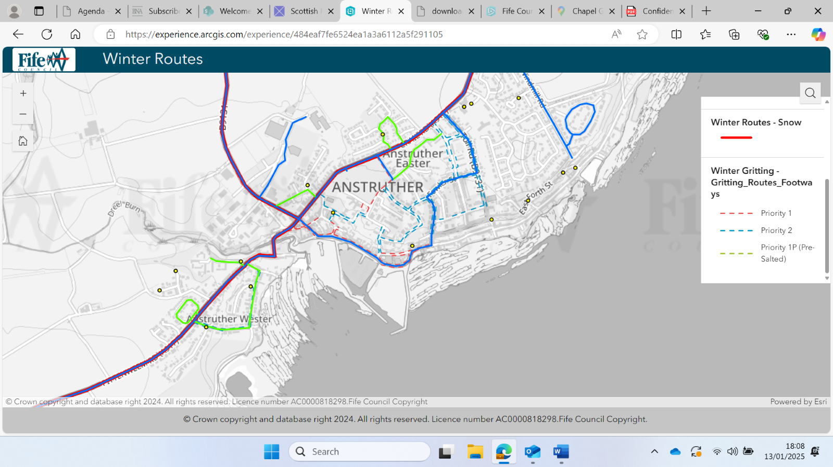

- Fife Place Plan
- www.Fife.gov.uk/fpp
- Share your ideas for Fife’s future. Let the council know what facilities your community needs, where there should be new housing, what infrastructure is required etc.
- Deadline: 24 Feb 2025
- On going road works:
- Pittenweem Road: Reaper Labe, opposite 59 Pittenweem Road – Road closure due to leak on ferrule
- Local communities are being invited by FC to have their say on the pressing issue of climate change and its impact on the Fife coastline as part of a Scottish Government case studies project to inform coastal management.
- Local Workshop 27 Feb 11am- 2pm
YMCA, Bonnygate, Cupar Climate Workshop Form

- Rent Consultation closes 31 January
- https://haveyoursay.fife.gov.uk/housing/rent-consultation-2025-26/

- Enrol your child in Primary 1 Now open, closes 9am 17 March 2025.
- https://www.fife.gov.uk/services/form-pages/enrol-a-child-into-primary-1

Planning/Licensing Matters
None of concern.

Common Good Fund

We have been advised by FC that:
‘As of 30th September 2024, there was a projected in year deficit of £3341 and the current revenue balance is £7,766 meaning there is effectively £4,425 available to support projects. I would urge caution however in using the revenue balance as it may make it more challenging to grow the fund through purchasing investments etc in the future’.

Application NERF1224 from Anstruther Harbour Festival could not be supported as:

"No applications for running costs on a recurring basis should be approved".
Suggestion: make applications for assets.
CllAHs answered the question KL asked last month as to whether / who insured Common Good Art / Artifacts. She stated it was covered under building insurance. KL asked how can they insured Art / Artifacts if they have not been valued. Cll AH is stated she would find out

Silverdykes Fund
The subcommittee reported its recommendations, and the whole CC discussed. The following decisions were returned, with a proviso that we need to revisit after contacting the friends of Bankie Park.

Cellardyke Tidal Pool Ltd — Decision: Fund, 100%
Tennis Club — Decision: Fund, 90%
Friends of Bankie Park — Application not complete. How many benches they want; where will they go; have they contacted Fife Council? Decision: Ask them to resubmit for their whole project. KL will ask Graham Ellery.
Rowing Club — Decision: Fund, 100%
Harbour Festival — Decision: Doesn’t meet the criteria.
Anstruther Primary school — Decision: No public access so does not meet criteria..

We have already written to the Primary School to say that unfortunately we could not put their application forward as it does not meet the Section 75 criteria:
'The monies can only be used for the provision of recreational or leisure facilities in open accessible space'
This is because the playground is not a public space accessible to all. However, we were able to advise that their project may be eligible for a grant from the Norah Webber Trust, and put her in touch with Glen Jones, who is a trustee of this fund.
— KL to reach out to Graham Ellery re the Friends of Bankie Park application.
— Revisit guide decision next meeting
— Chase whether skate park wants to go forward (otherwise £29000 come back)

Secretary’s Report

Santa Parade – This was very successful and thanks to all those who helped, including Andy Peddie for driving Santa, Santa himself and all his elves who ran alongside and collected donations. We did include Dreelside this year as requested, but turning was a bit tricky. Donations received amounted to £532.50. Donations to go to East Neuk First Responders.

Proposed Meeting to meet with Fife Council's Policy and Place Team – PA, BB, PW and LT expressed interest in attending, but no date for meeting has been received, even though it was meant to be last week or this. I did re-email to ask and received a response on Friday to say that they still haven’t had a date from the Development Plan Team.
Waid Campus – trying to arrange a meeting with Scott Duncan, Annette Mizerny and users in January.
Early Years/Nursery provision – Willie Rennie MSP been working with two people who were interested in setting up a nursery in the area, however, the current Care Inspectorate guidelines mean that the proposed venue is not suitable.
Parking in St Adrian Place – a member of the public contacted us expressing concern regarding obstructive parking at the junction with Bankwell Road. I wrote to Nigel Hampton at FC and he visited the junction but. there were no obstructively parked vehicles at the time of his visit. He said that the junction should be wide enough to allow passage past even with vehicles parked right up to the junction and that significant obstruction would only be likely if larger vehicles were present, such as HGVs. He said that photographic evidence would be very helpful, if this can be provided and I have passed this back to the member of the public.
Signage for overflow car park etc– Wrote to Nigel Hampton about this too. He said that signs to the Station Road car park already exist from the A917 junction. He has previously investigated installing signs to this from the town centre/harbour area but could not identify suitable locations, mainly due to narrow footways. He said he was not familiar with the car park behind the Co-op. and asked if it is a Fife Council owned/managed car park. When I explained that it was made by the RNLI as part of the planning for getting a new Life Boat shed, he said that FC would not therefore provide signage. Any signage would need to be supplied and funded by the parties involved, although FC would need to approve. He has also asked about timescales for the change of signage coming into Anstruther and the change of taxi bays to disabled bays. The road signage coming into Anstruther was changed on 19 November, although the road markings are not completed, but still waiting to hear about the parking bays. The 30mph signs have been moved but I am not sure about the larger junction warning signs for the Primary school access road junction – need to check this out.
Whatsapp group for KACCC – PA has asked about this (BB previously not keen) discuss. — Will make one
Police Report:
Anstruther
29 calls to the police. 4 crimes recorded
Cellardyke
15 calls to the police. 2 crimes recorded
Kilrenny
1 call to the police. 0 crimes recorded

Treasurer’s Report
Treasurers report to end of December 2024.

Bank Statement to the end of December - Total funds £68577.43
Community Council Management Funds to month end - £5757.56
INCOME.
Haven Raffle Proceeds - £125.90
Santa Collection - £532.50
Fife Council annual Grant - £908.56
Bank Interest - £236.37

Total Income - £1803.33

EXPENDITURE.
Haven Expenditure - £186.37
St Ayles Church Donation - £50.00
Fife Voluntary Audit of Accounts - £60.00
Hall Hire - £84.00
Bapaume Twin Town Hospitality - £338.30

Expenditure Total - £718.67

Representation from other groups
FLORAL - No Rep
MURRAY LIBRARY TRUST – Building renovated 10 years ago; maintenance needed: flat roof and first floor. Double glazed front windows permissions.

AOCB
AH: common good fund buildings insurance includes contents insurance. (Answer to KL.)
KL: meeting with LT (deputized by PW) and MH.
LT: In Providence USA Feb, Mar, April.
Can we have a Waid Rep? Ask Scott Duncan.
Status of web? BB: need to get web site brief to cost it. PW: annual hosting charge in March / April timeframe.
Barrier at top of Roger Street?
KL floral? Willing to look over the hanging baskets.

Date of next meeting 10 February 2025

Action Points
Silverdykes Applications: KL to reach out to Graham Ellery, MH to write to the Harbour Trust
Waid Rep – ask Scott Duncan - MH
Waid Campus – arrange meeting - MH

Abbreviations
FC – Fife Council
FCCT – Fife Coast and Countryside Trust
KACCC – Kilrenny, Anstruther and Cellardyke Community Council
MoP – Member of the Public
MUP – Multi Use Path

